Department of Electrical and Computer Engineering,

Gina Cody School of Engineering and Computer Science,

Concordia University, Montreal, Canada.

**COEN 6312– Model Driven Software Engineering – Winter 2024**

**“Library Management System”**

|  |  |
| --- | --- |
| **Name** | **Student** **ID** |
| Sai Teja Pamulapati | 40219371 |
| Pradheep Shankar | 40240136 |
| Srikanth Vadlamudi | 40232985 |
| Het Bimalkumar Shah | 40221304 |
| Abhinaw Siddharth Bogadhi | 40258258 |
| Kavya Murugan | 40195930 |

**Professor**: Wahab Hamou-Lhadj

**Teaching Assistant:** Md. Nazmul Hoq

Submitted On – 19th February,2024

# Abstract

In this report we are presenting our model of a library management system with domain analysis, textual description, potential users, list of features, use case diagram, functional and non-functional diagrams. In our system, we intend to represent the library resources accurately managed and bringing all the aspects of managing different resources of library to one digital platform.

Table of Contents

Abstract 2

Domain Analysis 4

Key Functionalities of LMS 5

Textual Description 6

Potential Users 7

List of Features 8

Use Case Diagram 9

Functional and Non-Functional Requirements 10

Functional 10

Non-functional 10

Conclusion 11

References 11

Table of Figures

Figure 1 Key functionalities of LMS 5

Figure 2 Potential Users 7

Figure 3 List of features for LMS 8

Figure 4 Ideal Use case Diagram for LMS 9

# Domain Analysis

A domain analysis for a Library Management System (LMS) delves into the systematic exploration of the library domain to understand the requirements, functionalities, and challenges associated with managing library operations. This analysis is crucial for developing a system that not only streamlines library processes but also enhances user engagement with library resources, both physical and digital. The library field encompasses a range of activities related to collecting organizing maintaining and distributing information resources. These resources include books, journals, magazines, newspapers, digital media and more. Libraries serve an array of users, with varying needs and expectations. This includes students, staff, and the public etc.,

Modern libraries face several challenges that necessitate the adoption of an efficient LMS. These include managing a growing and diverse collection of materials, providing easy access to digital and physical resources, ensuring efficient circulation of items, and maintaining accurate records of inventory, memberships, and transactions. Additionally, libraries need to adapt to the evolving expectations of tech-savvy patrons who demand quick and remote access to resources. Implementing an LMS can significantly enhance library operations and user experiences. It can lead to improved access to resources, streamlined workflows, and better inventory management. For patrons, it means quicker and easier access to a broader range of materials, both physically and online. For libraries, it translates into operational efficiency, better resource utilization, and the ability to adapt services to meet user needs more effectively.

# Key Functionalities of LMS

* ***Catalog Management:*** A core function of the LMS is to provide a robust cataloging system that supports comprehensive descriptions of items, including title, author, ISBN, publication details, and digital resource links. This system should accommodate various formats and facilitate easy searching and categorization.
* ***Circulation and Inventory Management:*** The LMS must efficiently manage the circulation of library materials, including checkouts, returns, renewals, and reservations. It should also keep accurate and real-time records of inventory, including the status of items as available, checked out, or reserved.
* ***Membership Management:***Managing user data, including registration, profiles, borrowing privileges, and history, is essential. The system should support different user roles and permissions, from administrators and librarians to general library members.
* ***Digital Content Access:*** With the increasing importance of digital collections, the LMS should facilitate access to e-books, online journals, databases, and multimedia content. This includes managing digital rights, licenses, and integration with external content providers.
* ***User Interface and Experience:*** The system should offer an intuitive and accessible interface for both patrons and library staff. For patrons, it should provide seamless navigation, efficient search capabilities, and personalized services such as book recommendations and alerts. For staff, it should offer tools for easy management of library operations.
* ***Analytics and Reporting:*** The LMS should be capable of generating reports and analytics to provide insights into usage patterns, popular titles, inventory levels, and member activity. This data is invaluable for decision-making related to collection development, marketing, and service improvements.

Figure 1 Key functionalities of LMS

# 

# Textual Description

Based on the domain analysis, the objective of the Library Management System (LMS) is to provide an effective and organized Digital system for managing library resources, like keep track of physical resources including books, tablets, DVD’s, stationery, presentation rooms and other materials as well as digital resources including e-books, audiobooks, e-magazines, newsletters that are currently available/borrowed.

The system aims to manage these assets with real time status updates of these assets for user convenience, automate various library operations like deadline and fine notifications etc., and improve user experience for both library staff and patrons.

The system also comes with various levels of access rights for different users. The access rights are briefly explained in the following potential user’s section.

A user needs to create an account using an e-mail address to access the system. Users can browse the catalogue to see the available resources, they can apply different filters to search the assets based on title, ISBN, edition, model etc., The catalog will also show if the assets are available to borrow or restricted to use in the library premises for certain assets like limited edition books etc., The catalog also displays the available presentation practice rooms and allows the users to book a time slot to reserve the room's. The user will get notifications for the asset return deadline as well as renewal to avoid paying fines and will also be able to pay fines using the LMS.

# Potential Users

For better understanding, in our library management system, we classify the users into academic and non-academic users. Academic users are those who are affiliated with the university that uses the library management system; this group comprises of staff, administrators or admin, librarians, and students. Non-academic users are those who are not affiliated with the university rather they could be outsiders, patrons or students who belong to other universities; this group consists of free users and paid users in our system.

* **Admin:** The admin the super user who has all the access rights to the LMS, the admin can block a user based on the activity like failed asset returns or any unauthorized activities.
* **Librarians:** Librarians are the main individuals in charge of maintaining the library's resources, taking care of administrative duties, and supervising daily activities and to perform all these activities they have access rights to features like adding, deleting the assets to the catalog, and updating the data about the assets etc.,
* **Staff:** Staff refers to the professors and other employees of that university as well as the library, with respective access limitation to utilize the library services to borrow books, search for materials, and access information resources.
* **Students:** Students refer to those who are currently enrolled the university courses to which the library belongs to, they have access to most of the resources for free like booking rooms, borrowing assets etc.,
* **Paid users:** Paid users are the individuals, who does not belong to university and needs a paid subscription to use the library resources.
* **Free users:** Free users are the individuals, who does not belong to the university who has extremely limited access to library resources and are mostly limited to browsing the available resources.

Figure 2 Potential Users

# List of Features

1. **Resource Management:**

* Add, edit, and delete books, journals, and other materials to the library catalog.
* Organize materials into categories and subcategories & provide floor, row, section, and shelf information for ease of navigation bar.
* Update item details such as title, author, publication date, ISBN/ISSN, and availability status, rental status, and access links.

1. **User Management:**
   * Register and maintain a database of library users/patrons/staff members.
   * Maintain all user accounts, library cards, contact information, borrowing history, Penalty status.
   * Provide user authentication and authorization mechanisms to control access to library services.
2. **Search and Discovery:**
   * To support search options, including keyword search, author/title search, and filters by format, genre, or subject.
3. **Staff and Administrative management:**
   * To set up admin/staff settings, including loan policies, penalty rates, and borrowing limits.
   * To browse through student/borrower’s history with library resources.

Figure 3 List of features for LMS

# Use Case Diagram

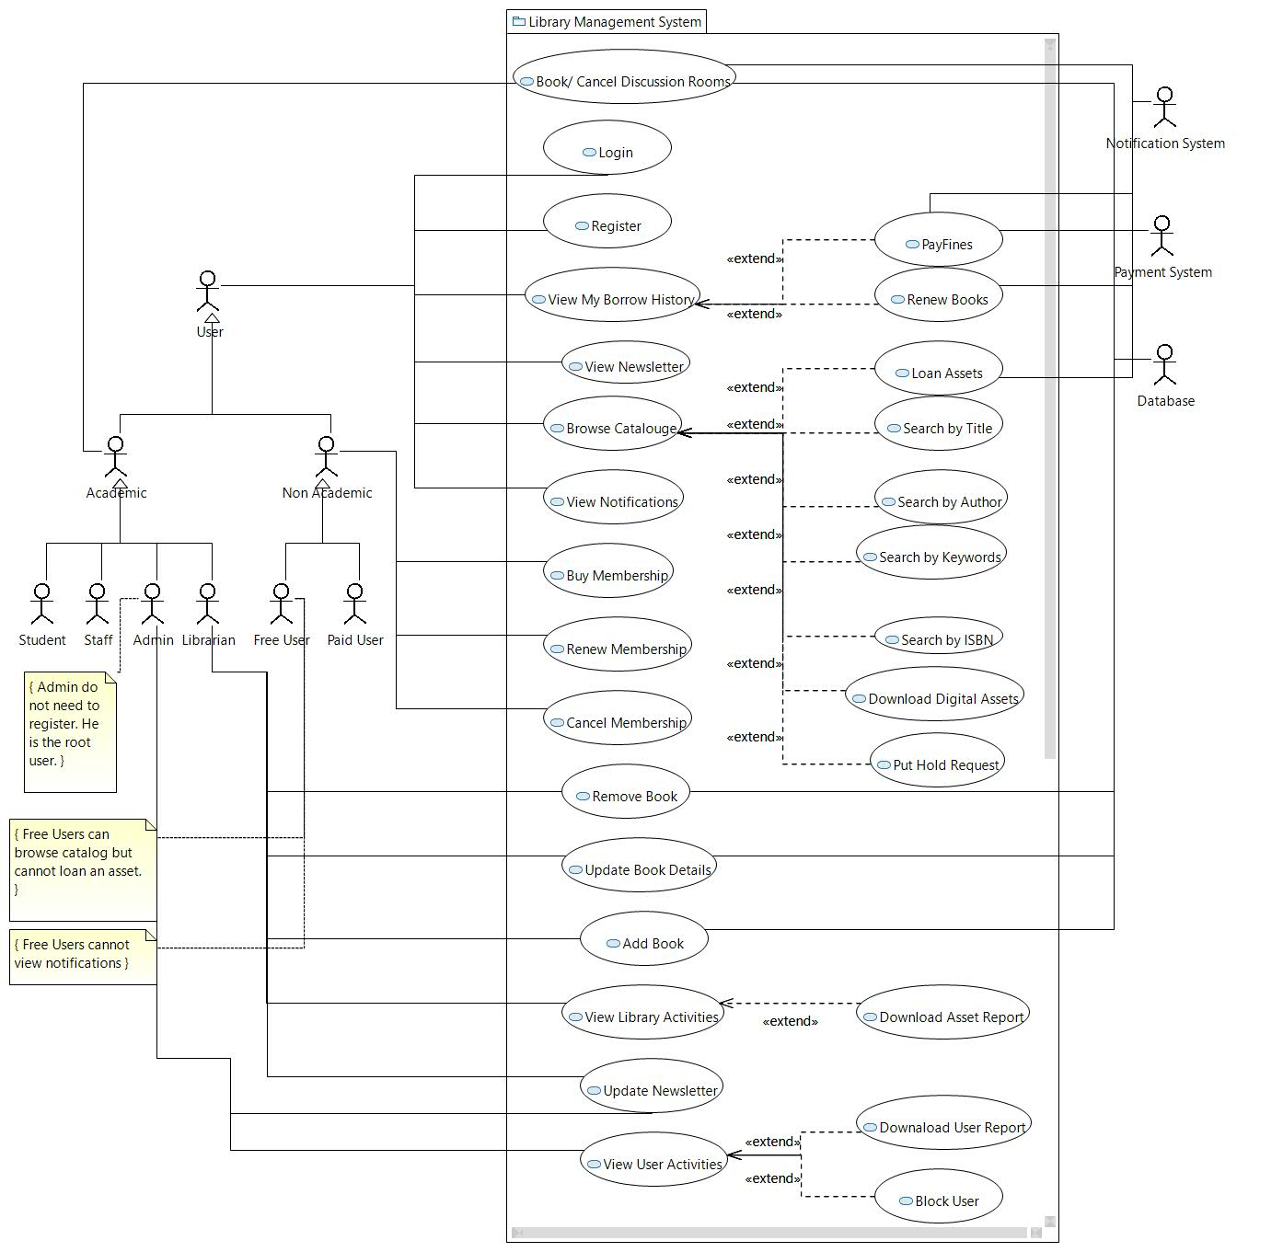

Figure 4 Ideal Use case Diagram for LMS

# Functional and Non-Functional Requirements

## Functional

1. As a user, I should be able to register to the Library Management System, so that I can use the LMS system.
2. As a user, I should be able to login to the Library Management System, so that I can use the LMS system.
3. As a user, I should be able to search the catalogue based on author, title, publisher, etc., so that I can borrow the books.
4. As a user, I should be able to borrow books/magazines, etc., so that I can read them.
5. As a user, I should be able to browse other assets like calculator, laptop, tablet, etc. in the library and loan them, so that I can use them.
6. As a user, I should be able to see my borrowing history, so that I can analyse it.
7. As a user, I should be able to pay for renewing books, so that I can keep using them.
8. As a user, I should be able to see the library’s newsletter so that I can keep track of what is happening at the library.
9. As a free user, I should be able to buy a library membership, so that I can use the library.
10. As a paid user, I should be able to renew/cancel my library membership, so that I can use the library.
11. As a librarian, I should be able to see all the activity happening in the library, so that I can monitor.
12. As a librarian, I should be able to edit/update/delete the asset details in the catalogue, so that the users can see the most updated information.
13. As a librarian, I should be able to download daily/monthly/yearly asset reports, so that I can analyse and take further actions.
14. As a librarian, I should be able to update the newsletter, so that users are updated on the activities happening at the library.
15. As an admin, I should be able to see all the user activities, so that I can monitor the users.
16. As an admin, I can block any users from the library for potential misuse, so that I can protect the library assets.

## Non-functional

1. As a User, I expect the system to load search results within 200ms for the 99th percentile user, so that I can quickly find the books I am interested in.
2. As a librarian, I expect the system to process check-in and check-out transactions in less than 50ms for the 99th percentile user, ensuring efficient service to members.
3. As a User who uses multiple devices, I expect the library management system to be accessible and fully functional on any device I choose to use, so I can manage my library account with ease.
4. As a library administrator, I expect the system to be available 99.999% of the time, ensuring continuous access for all users.
5. As a User, I expect the system to accurately reflect book availability and my account status in real-time, so I can rely on the information for my borrowing decisions.
6. As a User, I expect my personal and transaction data to be securely stored and transmitted, ensuring my privacy, and preventing unauthorized access.
7. As a User, I expect the library management system to be robust to handle any unexpected errors and have a low failure rate, so that the user experience will be good.

# Conclusion

We have designed the library management system with all the important real life use cases. We have outlined various functionalities and potential users. We included various assets that can be a part of a library management system like laptops, tablets, magazines, etc. Our potential users include academic and non-academic users since a library should be open to everyone. We have shown all the use cases in the use case diagram.

# References

1. Concordia University Library. <https://library.concordia.ca/>
2. Guidelines to Use Case Diagram. <https://community.wvu.edu/~hhammar/rts/Chapter4-Use%20Case%20Diagram.pdf>
3. Understanding constraints in use case diagram. <https://stackoverflow.com/questions/57206521/understanding-constraints-in-use-case-diagram>